Release of Information
*****Data sharing is the default setting in HMIS for new client data entered. It is imperative that every user know how to properly tag and upload the new universal ROI to protect the privacy and security of client data.
In this document:
- General ROI information
-What if the universal ROI is already uploaded?
-How to tag the ROI
-How to upload a copy of the ROI
_____________________________________________________________________________________
General ROI information
A release of information needs to be obtained and entered into HMIS for any client who’s information is being entered into the system. All household members 18+ must sign (or give verbal consent) for their information to be entered. Any minor who’s information is entered should be listed on the Head of Household’s ROI. A ROI for every person entered into HMIS should be signed (or verbal consent granted), uploaded and tagged. Every ROI needs to uploaded to the ROI tab. If your client does not want their information shared outside of your agency please review guidance avilable for “locking down” a client’s record.
What if the universal ROI is already uploaded?
Navigate (with EDA mode and Back date mode selected) to the ROI tab of your client’s record.
Only one agency needs to complete, tag, and upload the universal release. If you see “1 Universal ROI” tagged in the ROI tab then you do not need to add another one. Instead, you will need to look to the uploaded ROI to review the client’s specified preferences. If the universal ROI is tagged, but there is no ROI uploaded, you will need to upload the ROI.
Uploaded ROI with client’s preferences

Uploading the universal ROI
If you do not see the universal ROI tagged or uploaded, you will need to do so.
Navigate (with EDA mode and Back date mode selected) to the ROI tab of your client’s record.
Click “Add Release of Information” button and the ROI sub assessment will pop up.
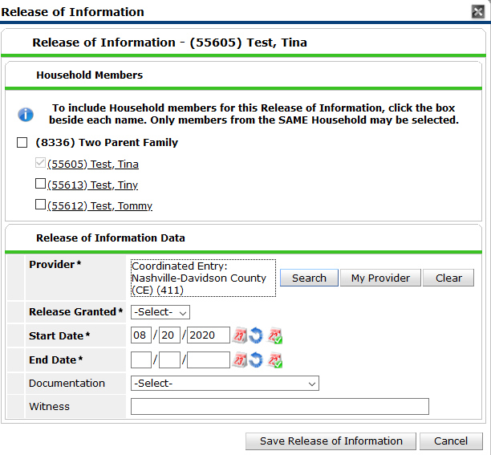
The EDA mode you are in will be listed as the Provider. Click “Search” and a screen with additional providers will pop up.
Include all household members that are included on the ROI
Once both are listed, click the “Exit” button.

Click the green + button next to “1 Universal ROI” to add it to the other provider listed. This will make the ROI visible to any program or provider using HMIS.
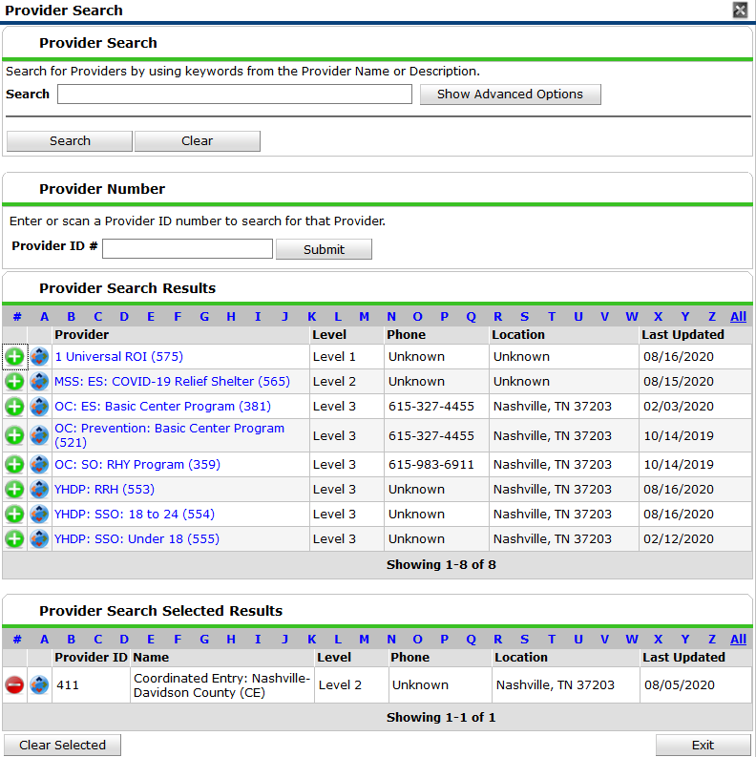
The “1 Universal ROI” will show up at the bottom with the other Provider.
The Release of Information box will pop back up with the both providers listed. (See below)
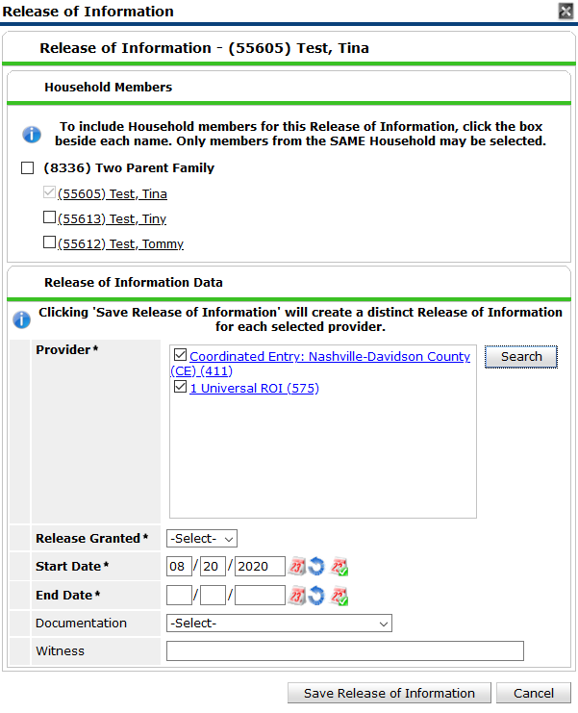
The ROI is valid for 3 years. Set the end date.

If you have collected a ROI select “Yes” for release granted.

Sign as the witness. This adds another level of accountability for client data.

Identify whether there is a signed ROI or if verbal consent was granted (An upload of an ROI is required regardless)

Make sure to include all household members represented on the ROI

Uploading the ROI
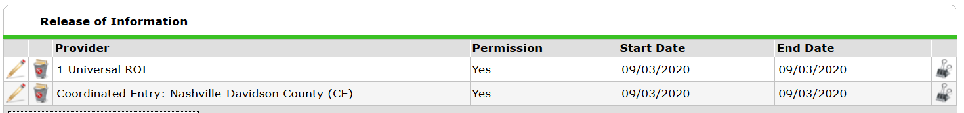
Whether you have collected a written signature or a verbal agreement you will upload it to the “1 Universal ROI” by clicking the binder clip icon on the right side.
If your client did not sign to share their information across agencies, you will not tag the Universal ROI. Look to guidance available on how to “lock down” a client’s record so that their information isn’t shared.

